Workplace Cleaning Guide



Anti-Viral And Deep Cleaning – Controlling The Risk:-

Whenever and wherever cleaning is taking place, it is extremely important that all potentially harmful dirt and bacteria are prevented from travelling around the building. The anti-viral and deep cleaning services that we provide are the perfect way to make your property look the best it ever has and reduce the risk of infection spreading.
From building works and renovation to just an intense periodic clean, you can rest assured that all of our cleaning operatives adopt effective infection control procedures. With many years of experience, our cleaning teams are professionally qualified to performing a high standard, heavy duty, full scale deep cleaning from top to bottom and anti-viral fogging.
The infection risk from COVID-19 following contamination of the environment decreases over time. It is not yet clear at what point there is no risk however, studies suggest the risk is likely to be reduced significantly after 72 hours.
The deep cleaning process should take place periodically throughout the year and the anti-viral fogging service on a more regular basis in addition to the normal daily / weekly cleaning regime. These services are different to a regular clean as they reach the deep areas within your property that would otherwise not be cleaned.



COVID-19: Cleaning In Non-Healthcare Settings:-

Wear disposable or washing up gloves and aprons for cleaning.
Cleaning the area with normal household disinfectant after someone with suspended coronavirus has left will reduce the risk of passing the infection on to others.
Only use disposable cloths to clean and first clean hard surfaces with warm soapy water before using disinfectant. Ensure close attention is paid to frequently touched areas and surfaces, such as door handles, light switches and grab rails etc.
When you have finished cleaning double bag the apron and gloves and store securely for 72 hours before disposing of them in the regular rubbish.
Wear protection for the eyes, mouth and nose too if the area being cleaned has been heavily contaminated from a person with coronavirus, signs of this would be visible bodily fluids.
Wash hands regularly with soap and water for 20 seconds.

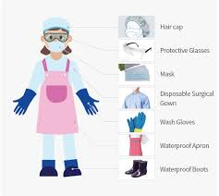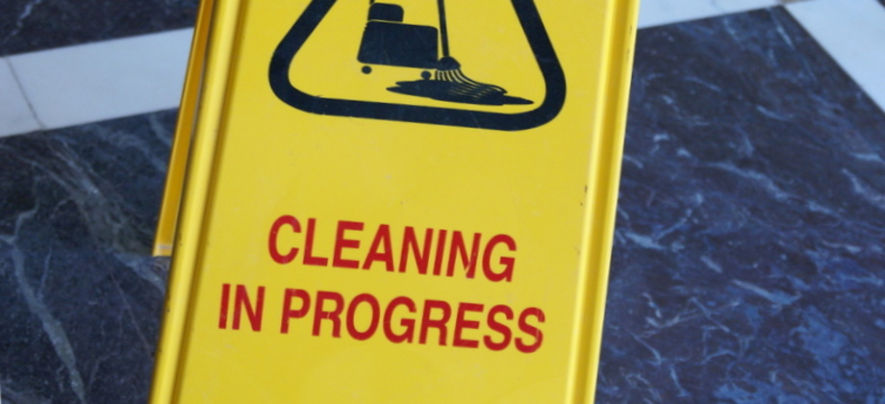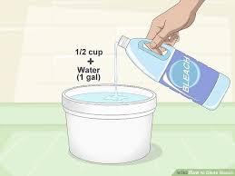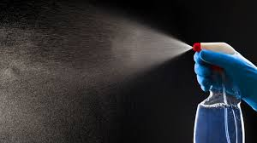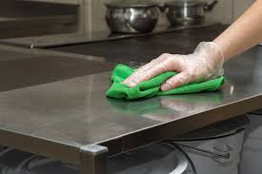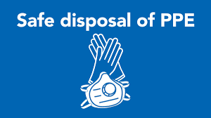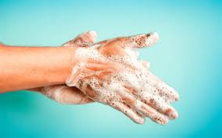

Colour Coding:-

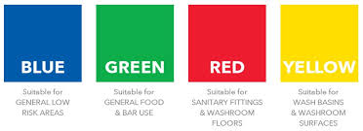

Some companies may adopt their own colour coded systems for cleaning, the importance is that once colours have been designated to particular areas this cannot be changed and must be adhered to at all times.

The aim of colour coding is to prevent cross contamination during the cleaning process and although there is no legal requirement to operate a colour-coded cleaning regime, it is considered good practice to do so when cleaning commercial premises.

Think equipment when colour coding and not just cloths for example buckets, mops, dust pans and scrubbing brushes.

Recommended usage is as follows:-

Blue – General Low Risk Areas
To include Classrooms, Offices, Corridors & Gymnasiums

Green – General Food And Bar Use
To include Kitchens and Cafeterias

Red – General Washroom
To include W/Cs

*Red / White is best practice for sanitary appliances

Yellow – Clinical
To include Medical Centres and Dental Practices

COVID-19: Effective Cleaning Products:-

In most cases, germs, bacteria and viruses are invisible however although we cannot see them it that does not mean they are not there. Left without cleaning, they will multiply or mutate increasing the risk of infection therefore in addition to cleaning using a colour coded system it is imperative that effective cleaning products are used as part of the cleaning regime.

Virucidal Cleaner – a powerful multi-purpose bacterial cleaner and sanitiser which is effective against non-enveloped and enveloped viruses including COVID-19, E-Coli, Salmonella and Norovirus. Passes EN 1276 / 14476 is what needs to be used.
We here at USS use Evan’s Safe Zone Plus, unperfumed and used in hospitals, clinics, surgeries and nursing homes, it is also recommended for schools, gymnasiums, sports and leisure centres etc

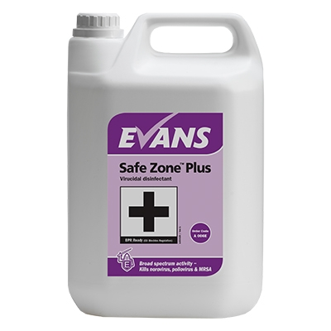

Ensure when using a virucidal cleaner that it passes EN14476 and has been tested against enveloped viruses.
Also ensure that the manufacturers instructions for dilution, application and contact times are followed.

In addition to virucidal cleaner, alcohol based sanitisers can be used, in particular these are good for food preperation areas etc. and cleaner disinfectant.

Waste Disposal:-

Prompt and efficient removal of waste also plays an important part in preventing the spread of infection.

All companies charged with handling waste, must develop rigorous systems to ensure that waste is disposed of properly. Effective waste disposal procedures will go a long way to reducing the risks associated with the spread of bacteria and infection.

Waste from possible cases of coronavirus and cleaning of areas where possible cases have been should be put in a plastic rubbish bag and tied when full, this included disposable cloths and tissues.

The plastic bag should then be placed into a second bag and tied and put in a suitable, secure place until the individual’s test results are known.

Waste should always be kept away from children and should not be put in communal areas until negative test results have been received or the waste has been stored securely for at least 72 hours.

If storage for at least 72 hours is not appropriate, collection as a Category B infectious waste by your local waste collection authority or a specialist clinical waste collector needs to be arranged.

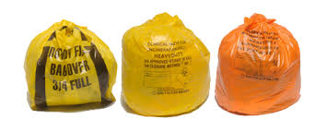

Hand Hygiene:-

Good hand hygiene is the primary most important method of preventing cross contamination and the spread of germs and bacteria.

The importance of hygiene in the workplace should never be underestimated and it is standard practice throughout the cleaning sector to provide protective gloves to staff when carrying out most tasks.

Hand should be still be thoroughly cleaned before and after gloves are worn as effective had washing removes or destroys harmful bacteria picked up by the hands.

The aim of good handwashing practices is to ensure your own protection and prevent the transfer of bacteria to others.

Technique is more important than the type of hand cleanser used although tablet soap is not advised and when washing hands, the following points should be adopted by all staff:-

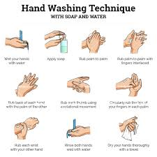

Ensure jewellery is removed prior to hand washing and when disposing of the paper towel used to dry hands in a waste bin that the bin is not touched.

Moisturising hands after washing will prevent hands from become chapped and sore and any cuts or abrasions on the hands should be covered with a clean water-proof dressing.

If using hand sanitiser, apply 2 to 3 pumps into clean, dry, capped hands and follow the technique above rubbing until hands are dry, this should take at least 30 seconds.

PPE (Personal Protective Equipment):-

Ensure staff are protected from health and safety risks in the workplace and provide PPE where appropriate.

Government guidance advises that the minimum PPE to be worn when carrying out cleaning tasks in area of suspected coronavirus is an apron and disposable gloves. USS goes above and beyond this and provides all of our operatives with disposable gloves, facemasks, disposable overalls and disposable shoe coverings.

Where there is visible contamination with body fluids, goggles are also provided.

All staff should be trained in the correct use of a face mask and how to fit it.

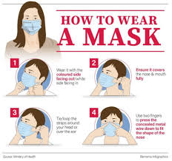

Returning To Work Safely:-

Before workers, customers or visitors return, premises should undergo a deep clean or anti-viral fogging to eliminate any traces of bacteria.

Carry out a COVID-19 risk assessment.

Display clear notices around the workplace reminding people of the importance of hand washing and social distancing etc. and ensure only one person is assigned to a work station.

Encourage staff to keep their individual workspace hygienically clean by providing disposable cloths, gloves and a ready to use cleaning solution or disinfectant for them to wipe down their space throughout their working day.

Provide hand sanitiser throughout the workspace in particular nearby to high touch traffic points e.g. lift buttons, telephones and door handles.

Avoid busy canteen areas where possible by providing refreshment facilities for each workstation, department to reduce members of staff spreading germs to each other and stagger shift patterns etc.

For additional cleaning advice and support, contact USS on 020 8669 4377.

