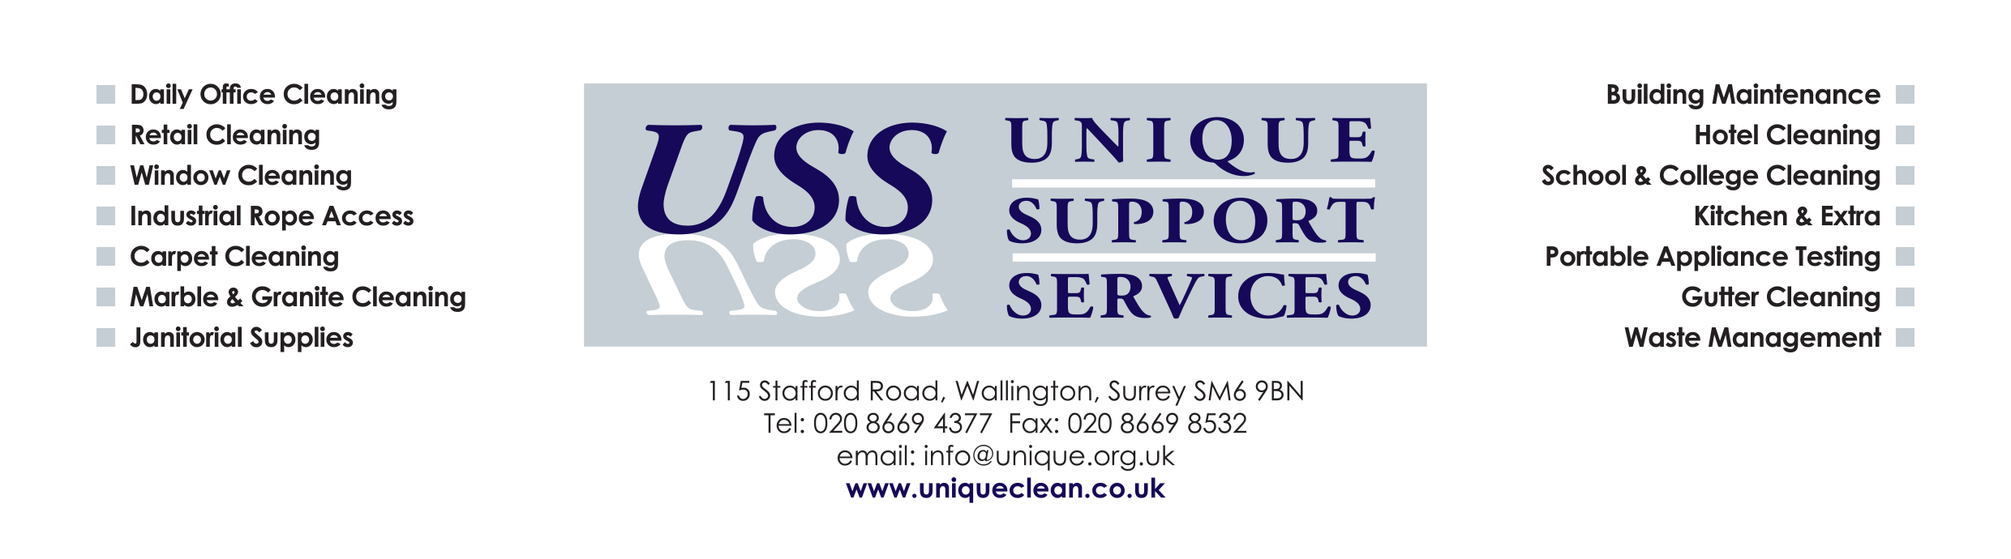
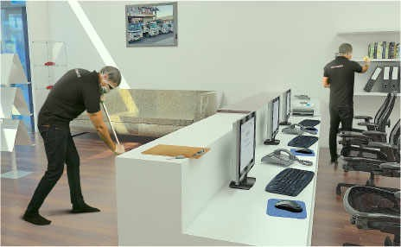

PROFESSIONAL DEEP CLEANING SERVICES
LET US DO THE DIRTY WORK
Providing first class cleaning and property maintenance services for commercial clients is our area of expertise and our cleaners have been doing so for over two decades. With many years of experience, our cleaning teams are professionally qualified to performing a high standard, heavy duty, full scale deep clean from top to bottom using virucidal disinfectant and wearing appropriate PPE.
OUR SERVICES ALSO INCLUDE:-
Carpet and Upholstery Cleaning, IT and Telephone Cleaning, Window Cleaning and General Office Cleaning.
Our clients appreciate that when they hire us, they are hiring a company that will remain professional to the end of the cleaning project, will clean and maintain their property to the highest possible standard and whatever your cleaning requirements, our reliable and dedicated cleaners have the experience, expertise and skills to meet them perfectly and exceed your expectations.
WE’RE HERE TO HELP YOU WITH YOUR RESOLUTIONS 24 HOURS A DAY, 365 DAYS OF THE YEAR
ONE OFF AND PERIODIC CLEANING AVAILABLE
Call us for a FREE no obligation quotation FREEPHONE: 0800 9774860 or email your enquiry to info@unique.org.uk and a member of our team will call you back

PROFESSIONAL DEEP CLEANING SERVICES
LET US DO THE DIRTY WORK
Providing first class cleaning and property maintenance services for commercial clients is our area of expertise and our cleaners have been doing so for over two decades. With many years of experience, our cleaning teams are professionally qualified to performing a high standard, heavy duty, full scale deep clean from top to bottom using virucidal disinfectant and wearing appropriate PPE.
OUR SERVICES ALSO INCLUDE:-
Carpet and Upholstery Cleaning, IT and Telephone Cleaning, Window Cleaning and General Office Cleaning.
Our clients appreciate that when they hire us, they are hiring a company that will remain professional to the end of the cleaning project, will clean and maintain their property to the highest possible standard and whatever your cleaning requirements, our reliable and dedicated cleaners have the experience, expertise and skills to meet them perfectly and exceed your expectations.
WE’RE HERE TO HELP YOU WITH YOUR RESOLUTIONS 24 HOURS A DAY, 365 DAYS OF THE YEAR
ONE OFF AND PERIODIC CLEANING AVAILABLE
Call us for a FREE no obligation quotation FREEPHONE: 0800 9774860 or email your enquiry to info@unique.org.uk and a member of our team will call you back

