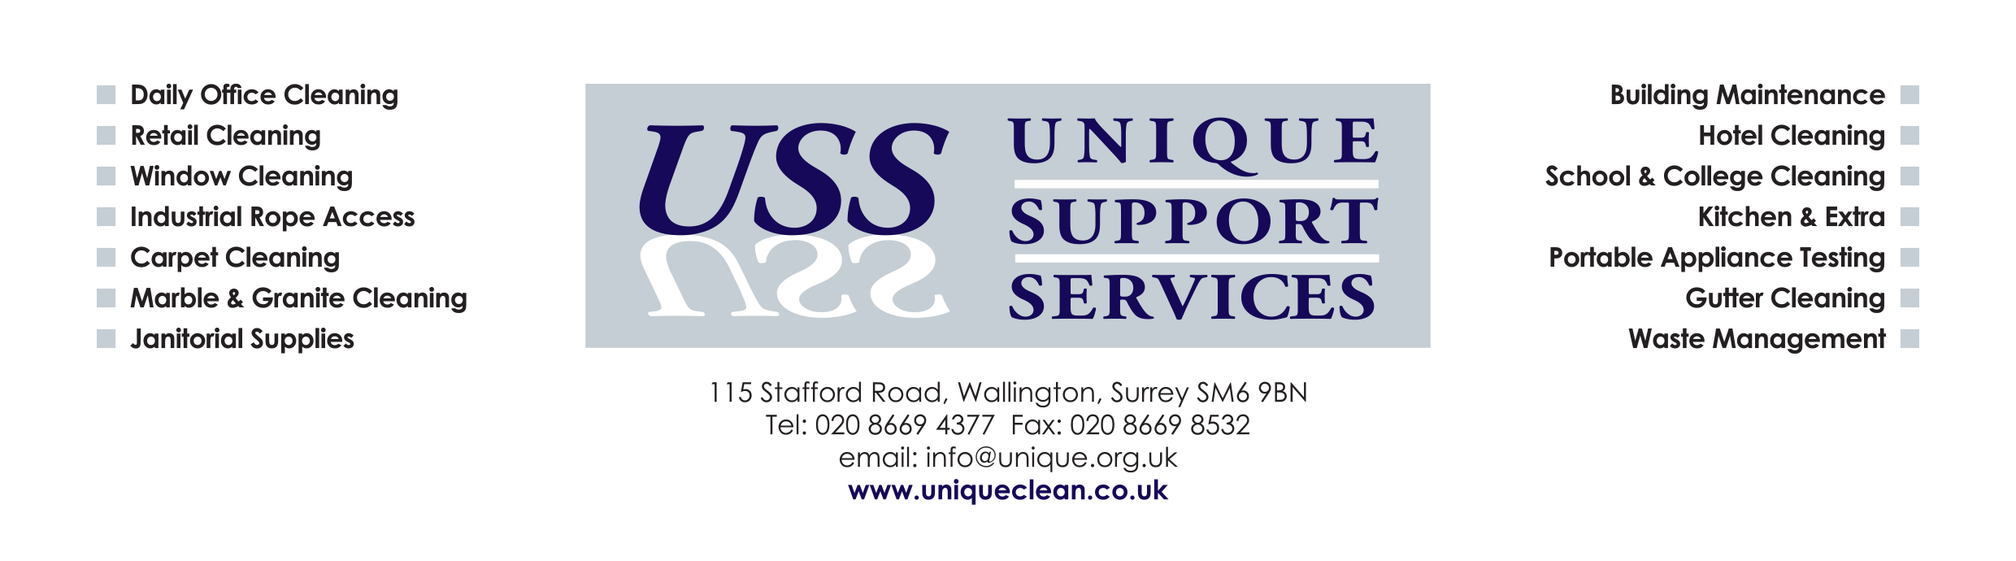


RING IN THE NEW YEAR WITH A NEW CLEANING CONTRACT
Providing first class cleaning and property maintenance services for commercial clients is our area of expertise and our cleaners have been doing so for over two decades.
OUR SERVICES INCLUDE:-
Internal and External Window Cleaning, Kitchen Deep Cleans, Marble, Granite and Glass Cleaning and Maintenance, Office Cleaning, IT and Telephone Cleaning and the Cleaning of all BOH, FOH and Public Areas within the Hotel sector.
But why do so many companies choose us over the many other commercial cleaning companies in London and Surrey? We offer:
Guaranteed quality
Unbeatable prices
Over two decades of professional cleaning experience
A dedicated, reliable and well trained team of cleaners and maintenance specialists
Our clients appreciate that when they hire us, they are hiring a company that will remain professional to the end of the cleaning project, will clean and maintain their property to the highest possible standard and whatever your cleaning requirements, our reliable and dedicated cleaners have the experience, expertise and skills to meet them perfectly and exceed your expectations.
WE’RE HERE TO HELP YOU WITH YOUR RESOLUTIONS
Call us for a FREE no obligation quotation FREEPHONE: 0800 9774860 or email your enquiry to info@unique.org.uk and a member of our team will call you back
New Clients will receive 10% off their first invoice value

