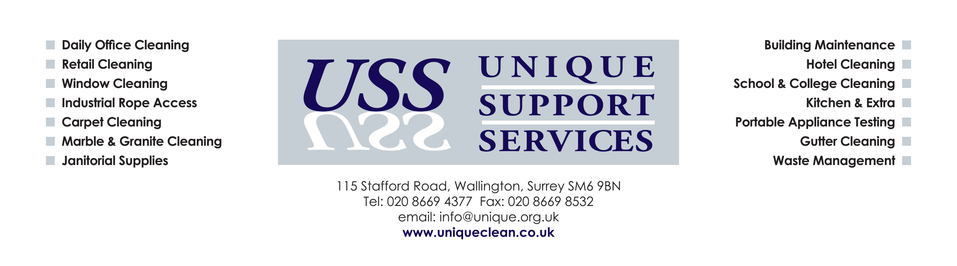

Environmental & Sustainability Policy

Unique Support Services Ltd is a commercial cleaning company and we recognise our responsibility for environmental protection and are committed to sustainability development.

We are committed to ensuring all reasonable steps are being undertaken to deliver only sustainable products and services to all our clients and that only sustainable products and services are purchased from our suppliers.

We acknowledge the impacts of our activities on the environment at all levels, therefore seek solutions to environmental problems by adopting sound principles and best practice.

Environmental regulations, laws and codes of practice will be regarded as setting the minimum standards of environmental performance.

The objectives of this policy are:

- Encourage suppliers and clients alike to conduct operations in an environmentally efficient manner.
- Recycling and encouraging suppliers to recycle wherever possible including metals, paper, plastics and electrical equipment.
- Promote diversity and equality within the workforce via recruitment and retention.
- Encourage use of new working systems, methods and equipments to continually improve our carbon footprint.
- Promote the protection of the environment and minimise the impact of activities upon local, regional and global environments.
- Integrate environmental management policies and practices into every level and every department of the company.
- Provide safe, healthy working conditions for staff and others.

In order to achieve the above Unique Support Services Ltd aims to:

- Minimise waste, especially hazardous waste, and wherever possible recycle materials. We will dispose of all waste through safe and responsible methods.
- Avoid the unnecessary use of hazardous materials and processes and take all reasonable steps to prevent damage to either public or ecological health where such materials are in essential use.

- Reduce the use of water wherever possible and use environmentally friendly cleaning products when suitable.
- Use recycled and recyclable materials where appropriate, choosing products and suppliers with minimise negative environmental impacts.
- Coordinate route planning, we will seek to realise the dual benefits of reduced fuel consumption and lower exhaust emissions.
- Carry out risk assessments to identify the types and scale of the environmental risks involved
- Buy energy efficient appliances and equipment.
- Assess the chemicals we use for their environmental impact through COSHH and environmental assessment and consider our choice of chemicals, materials and cleaning techniques with environmental impact in mind.
- Implement our policies through guidelines and training.
- Increase awareness of environmental responsibilities among staff
- Endeavour to assess every major new initiative for its environmental costs and benefits.

