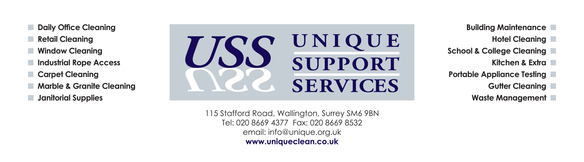

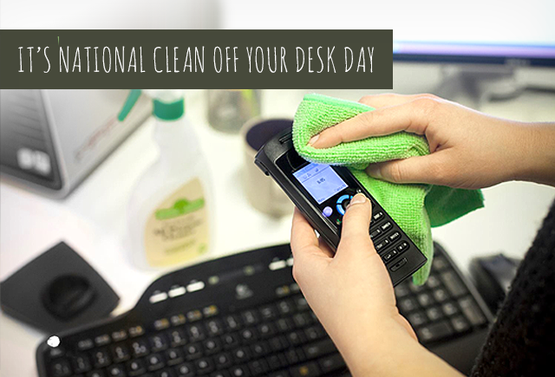

In Addition to General Office Cleaning, Unique Support Services Portfolio of Services Includes:-

PC Cleaning (screen, keyboard and mouse)
Base Unit Cleaning
Telephone Cleaning

Full clinical cleaning of all outer casings, Label Residue and Graffiti removal, Vacuuming to Keyboards and Vents (where accessible) and various Screen Treatments.
Telephone Hygiene Service incorporates full clinical cleaning to all outer casings with Bacteria Repellent to Handsets.

Competitive prices available on request.

Enquire today by calling 020 8669 4377 or by emailing info@unique.org.uk

